Dear Friends,
Time truly does fly when you are having fun! We sure have been having loads of fun here at Maspeth Town Hall during the summer. Our Summer Rising program was a great success, having serviced 1,900 children. Our campers were engaged for 10 hours a day, five days a week with enriching academic and recreational activities. Of course, this would not be possible without the dedicated work of our Director of Operations, Sean Kearney. As well as our Program Supervisors; Bill Donovan, Bill Dobranski and Andrea Solares. They did a fantastic job supervising the summer camp and ensuring that our programming ran smoothly. Of course, we cannot forget our hard working Summer Program Directors; Lorraine Finocchiaro, Arlene Solares, Crystal Samuels, and Seida Muratovic who were supported by over 200 workers. Our staff in the main office were equally as busy getting ready to open 13 After School sites for this upcoming school year. The hard work, dedication, creativity and commitment that we received from each of our staff members ensured the success of our program.
This past June, for the first time, we held a Staff Appreciation BBQ with more than 100 employees attending. Everyone enjoyed the food, the music, photo booth and the ice cream trucks. A special thanks to Wayne Zimmermann who was our DJ during this event, and truly brought the event to life with music suitable for all age groups. Many of our Board of Directors attended the event, and it was great to see everyone having such a nice time.
We are getting ready to send out our yearly “Thanks for Giving” calendar. We hope that you will be able to support this fundraiser. The profit from this Fundraiser helps with our General Operating Expenses. Please see below for more information.
Finally, I would like to thank Councilmember Robert Holden for his generous allocations to Maspeth Town Hall. Not only for our After School Programs but for our Senior Programs as well. With the funding from the City Council, many families in our town and our surrounding communities of Woodside, Ridgewood and Rego Park are being helped. It is because of this funding that Maspeth Town Hall can act as a fiscal conduit for a number of Food Pantries in the neighborhood. Additionally, we would like to thank City Council Speaker Adrienne Adams for her allocation to our center.

Eileen Reilly,
Executive Director

Newsletter Designed By: Shana Spiegel
After School Job Openings

Thirteen MTH After-School Programs located in Elmhurst, Maspeth, Woodside, Middle Village, Corona, Ridgewood & Glendale.
Candidates can earn between $16.00 - $35.00 per hour depending on their resume and qualifications.
Preferred availability 5 days a week, approximately 2:00PM - 5:30PM; minimum requirement of 3 days at those times. Must complete a thorough background check & be fully vaccinated against COVID-19.
Ability to speak a second language is a plus but not necessary. Job responsibilities include assisting elementary and middle school youth with homework and STEM activities.
Must also attend paid professional development trainings.
For more details and to apply, visit our website at
www.MaspethTownHall.org/Employment or email hiring@maspethtownhall.org
Welcome To The 2022 – 2023 School Year
After running a successful summer camp, our After School programming is set to begin September 19th, 2022. Maspeth Town Hall is proud to service families in thirteen schools across Queens. Some of these programs are funded through City and State Grants, while others are fee based programs. We strive to offer programs that allow the children to receive homework help while also engaging them in many recreational and educational activities. These activities include, but are not limited to Arts & Crafts, Musical IQ, Cosmo IQ, OSMOS, Story Time/Ready Readers, STEM (Legos), Dance and Sports Leagues.

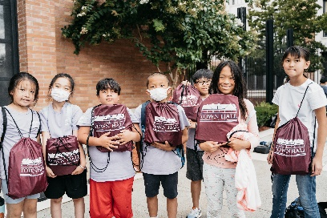

Senior Programs

Maspeth Town Hall currently has openings in the Senior Art, Tai Chi, and Chair Yoga classes!
​
Please call us at (718) 335 - 6049 ext. 105 for more information on available class schedules and how to register. Seats are limited and will be given on a first come, first serve basis.
​
We will be following social distancing guidelines so the class will be smaller in size.

Mommy & Me Classes

Maspeth Town Hall is currently offering Mommy & Me classes for the following age groups:
Under 2, 2 year old toddlers, and 3 year old toddlers.
​
Please call us at (718) 335 - 6049 ext. 104 to set up an appointment for registration. We will need your email so we can send you the application and toddler information in advance.
​
We will be following social distancing guidelines so the class will be smaller in size.

Program Suggestions
We want to hear from YOU! Tell us what activities you are interested in or a class you would love to see here at Maspeth Town Hall. Please send us an email at info@maspethtownhall.org

Teen Drama Program (Ages 13 & Up)

The drama is back at Maspeth Town Hall! Please join us for registration on October 7th & 14th, 2022 from 6:30pm – 8pm at our main office located at 53-37 72nd Street, Maspeth NY, 11378
​
Drama Club will meet on Fridays from 7pm – 9pm. Classes will meet at the MTH main office (address above) for the first few weeks, and then transition to PS 229.
​
We are happy to welcome back Heidi Stallings as out drama instructor!

If there are any alumni who wish to volunteer their time in this program please come to registration and speak with Heidi.

Thanks For Giving Calendar

Through the generosity of our Board of Directors and the business community, we can offer a calendar full of great prizes for every age group! (Handbags, gift cards, cash and much more)
Each calendar costs $20.00 and buys you 30 CHANCES (once every day in November) to win! With fabulous prizes ranging anywhere from $200 - $600.
For every 3 calendars that YOU sell, your name is entered into the ELITE SELLERS RAFFLE. Here you can win prizes ranging in value of $300 -$1,000!
For more information please call us at (718) 335 – 6049 OR visit us at www.maspethtownhall.org
** Calendars will be available at Maspeth Town Hall beginning in October and your chances to win will begin November 1st, 2022 **

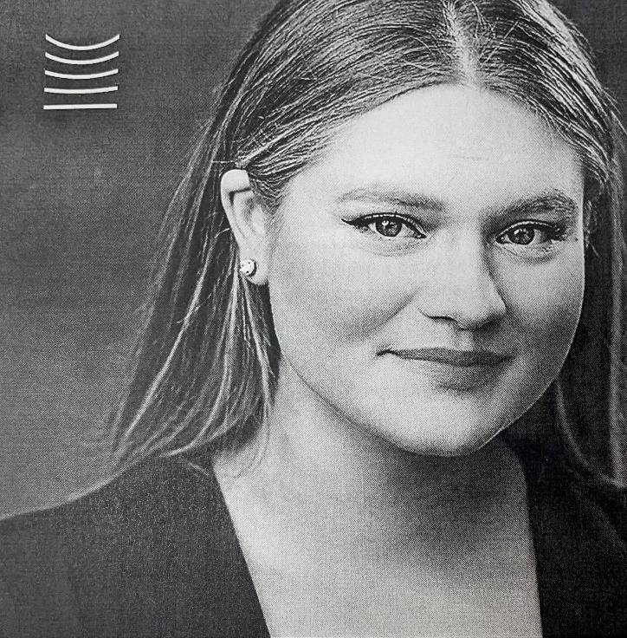
Speaking of Drama…

From the Maspeth Town Hall drama program, to winning the Metropolitan Opera Lafront Competition…. A special congratulations To Magdalena Kuzman!

To our rising opera star, we at Maspeth Town Hall wish you all the best and continued success!

MTH Board of Directors
Robert Aiello, Esq. – President Madeline LaFauce - First Vice President Eileen Hagen – Second Vice President
James F. O’Kane - Treasurer Leonard Masone, Esq. - Recording Secretary Mary Ellen Beirne – Corresponding Secretary

Board Members: June Osman, Joseph Papavero, Kenneth Rudzewick, MaryAnna Zero, Laura Zimmermann, Barbara Pryor, Esq., Dennis Cappello, Esq.

Eileen Reilly - Executive Director
Sean Kearney – Director of Operations

Corporate Members

APEXX Omni-Graphics, Inc.
Barbara Pryor Esq.
Frank’s Deli
Grand Florist
Iavarone Bros. of Maspeth, Inc.
Knockout Pest Control
Prymas Contracting
Ken & Barbara Rudzewick
Maspeth Press
The McGarvey DePuy Family
O’Kane Realty
Rosemary Kruh
Benefactors

Maspeth Federal Savings Bank
Cono & Mary Grasso
Charles & Margaret Markey
Robert Aiello, Esq.
Suzan Fezzuoglio
Wayne & Laura Zimmermann

Our Sponsors

Program Sponsors
The Coltrinari Family
Craftsman Woodworkers, Ltd.
Papavero Funeral Home
Jessica D’Antonio

Grants Received Through The Following City & State Agencies
NYC Department of Education
NYC Department of Youth & Community Development
NYS Office for the Aging
NYC Department of Health -Test & Trace Program
NYS Office of Children & Family Services
Expanded Ed.

Patron Members

Amparo Martinez
John McCormick
Peter Wolyniec
Catherine Franquinha
Jennifer & Mark Lopez
Joelle & Richard Matuszewski
Kathy Triebe
Joseph & Vanessa Papavero
Robert & Eileen Reilly
Julianna Wiessner
Marta Bialek

Maspeth Town Hall Membership Cost
If any member is interested in running for a position on the Maspeth Town Hall Board of Directors please contact Eileen Reilly @ (718) 335 – 6049 Ext. 101
Meetings are typically held on the 3rd Tuesday of every month @ 5pm at the Maspeth Town Hall office (Except for December, July & August)
This years election with be in June 2022. Please call before the end of May 2022 if you are interested.
Thank You
Robert Aiello, President

$500.00
$250.00
$100.00
$50.00
$25.00
$15.00
$10.00
Benefactor
Program Sponsor
Corporate Member
Patron Member
Family Member
Individual Member
Senior Citizen

